EXTRA SERVICES

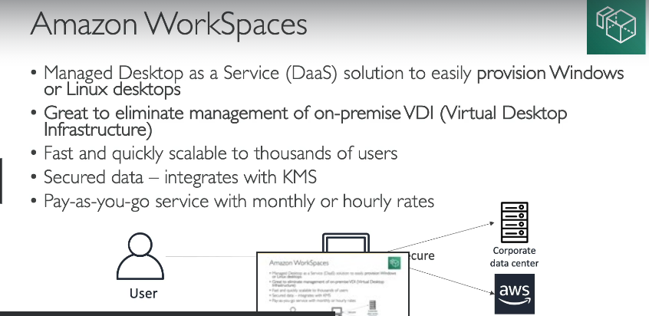

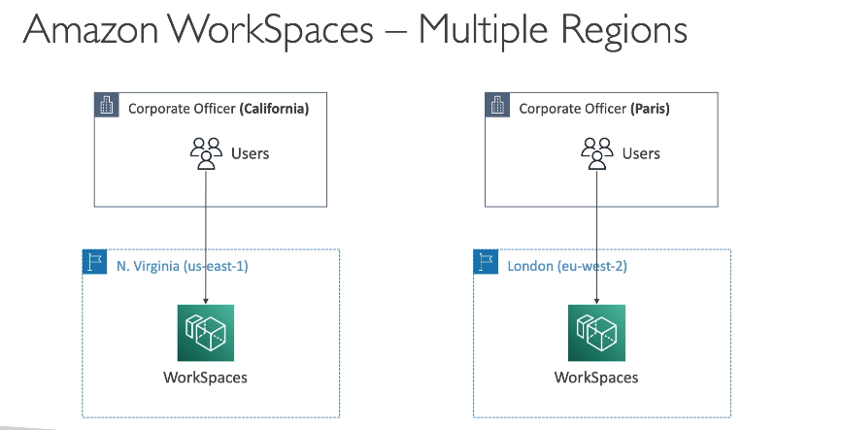

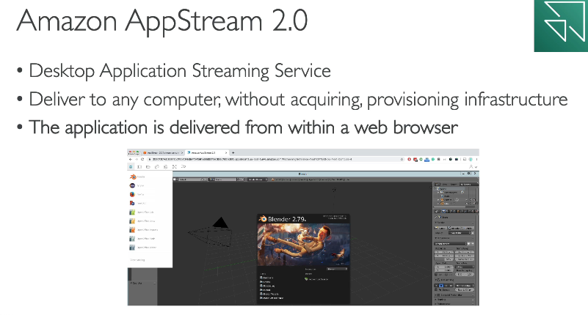

| **Amazon AppStream 2.0** | **WorkSpaces** |
| --- | --- |
| Stream a desktop application to web browsers (no need to connect to a VDI) | Fully managed VDI and desktop available |
| Works with any device (that has a web browser) | The users connect to the VDI and open native or WAM applications |
| Allow to configure an instance type per application type (CPU, RAM, GPU) | Workspaces are on-demand or always on |

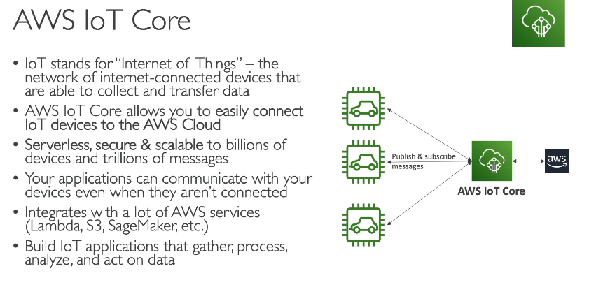



**AWS AppSync**

* Store and sync data across mobile and web apps in real-time
* Makes use of GraphOL (mobile technology from Facebook)
* Client Code can be generated automatically
* Integrations with DynamoDB / Lambda
* Real-time subscriptions
* Offline data synchronization (replaces Cognito Sync)
* Fine Grained Security
* AWS Amplify can leverage AWS AppSync in the background!



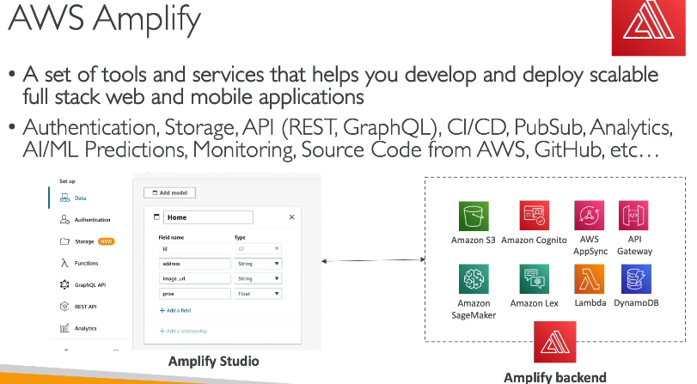



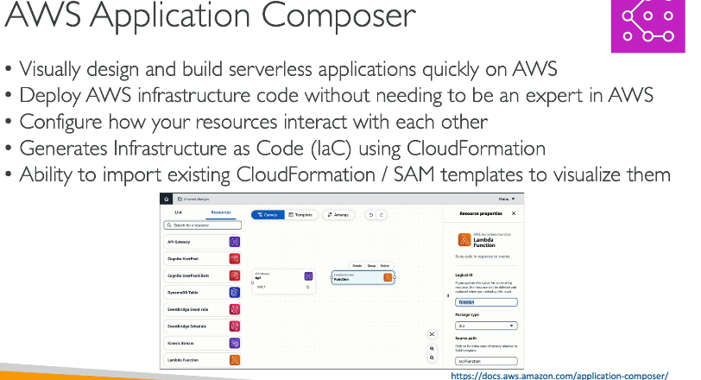



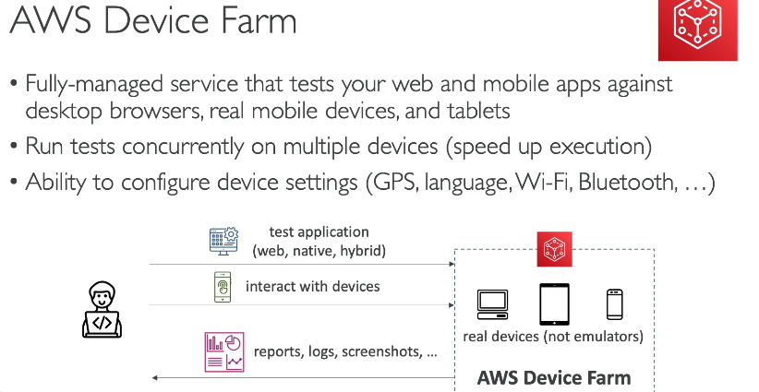



**WS Backup**

* Fully-managed service to centrally manage and automate backups across AWS services
* On-demand and scheduled backups
* Supports PITR (Point-in-time Recovery)
* Retention Periods, Lifecycle Management, Backup Policies,etc.
* Cross-Region Backup
* Cross-Account Backup (using AWS Organizations)

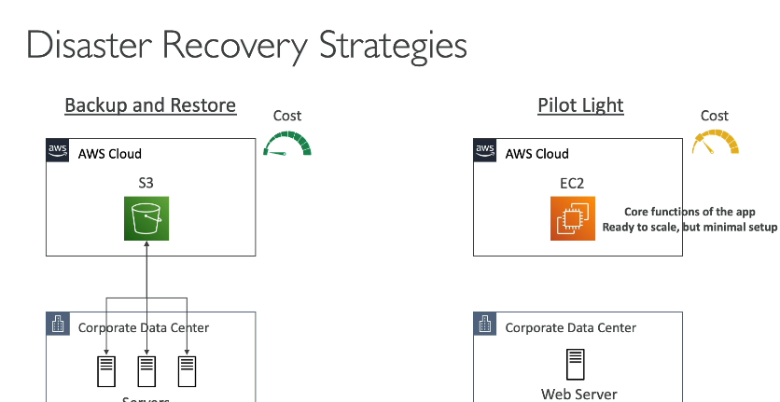

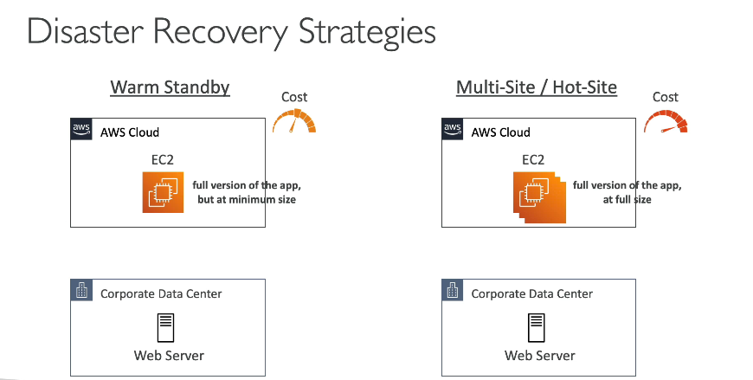



**AWS Elastic Disaster Recovery (DRS)**

* Used to be named “CloudEndure Disaster Recovery”
* Quickly and easily **recover** your physical, virtual, and cloud-based servers into AWS



* Example: protect your most critical databases (including Oracle, MySQL, and SQL Server), enterprise apps (SAP), protect your data from ransomware attacks, …
* Continuous block-level replication for your servers

**AWS DataSync**

* Move large amount of data from on-premises to AWS
* Can synchronize to: Amazon S3 (any storage classes – including Glacier), Amazon EFS, Amazon FSx for Windows
* Replication tasks can be scheduled hourly, daily, weekly
* The replication tasks are incremental after the first full load

**AWS Migration Evaluator**

* Helps you build a data-driven business case for migration to AWS
* Provides a clear baseline of what your organization is running today
* Install Agentless Collector to conduct broad-based discovery
* Take a snapshot of on-premises foot-print, server dependencies,...
* Analyze current state, define target state, then develop migration plan

**AWS Migration Hub**

* Central location to collect servers and applications inventory data for the assessment, planning, and tracking of migrations to AWS
* Helps accelerate your migration to AWS, automate lift-and-shift
* **AWS Migration Hub Orchestrator** - provides pre-built templates to save time and effort migrating enterprise apps (e.g., SAP Microsoft SQL Server...)
* Supports migrations status updates from Application Migration Service (MGN) and Database Migration Service (DMS)

**AWS Fault Injection Simulator (FIS)**

* A fully managed service for running fault injection experiments on AWS workloads
* Based on **Chaos Engineering** – stressing an application by creating disruptive events (e.g., sudden increase in CPU or memory), observing how the system responds, and implementing improvements
* Helps you uncover hidden bugs and performance bottlenecks
* Supports the following AWS services: EC2, ECS, EKS, RDS…
* Use pre-built templates that generate the desired disruptions

**AWS Step Functions**

* Build serverless visual workflow to orchestrate your Lambda functions
* Features: sequence, parallel, conditions, timeouts, error handling, etc.
* Can integrate with EC2, ECS, On-premises servers, API Gateway, SQS queues, etc.
* Possibility of implementing human approval feature
* Use cases: order fulfillment, data processing, web applications, any workflow

[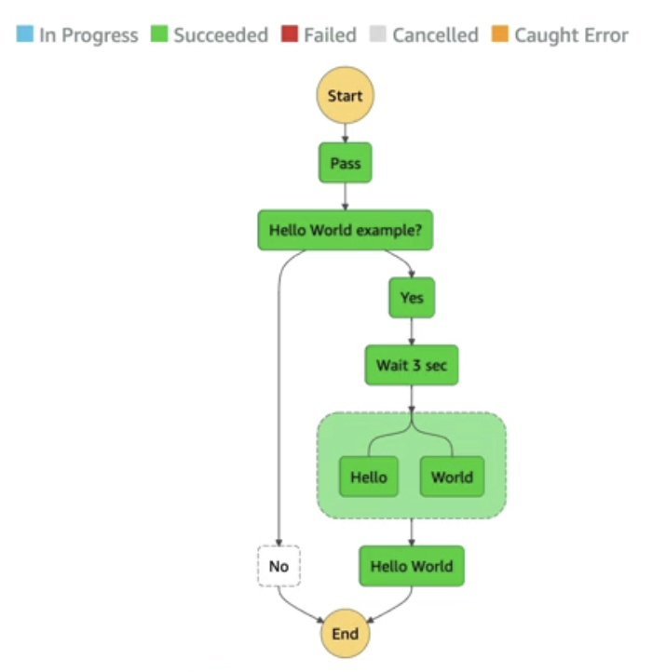](https://github.com/kananinirav/AWS-Certified-Cloud-Practitioner-Notes/blob/master/images/step_functions.png)

**AWS Ground Station**

* Fully managed service that lets you control satellite communications, process data, and scale your satellite operations
* Provides a global network of satellite ground stations near AWS regions
* Allows you to download satellite data to your AWS VPC within seconds
* Send satellite data to S3 or EC2 instance
* Use cases: weather forecasting, surface imaging, communications, video broadcasts

PINPOINT,250 LECTURE